5th Grade

Monday | Gym
Tuesday | Art
Wednesday | Music
Thursday | Library/  Swep
Friday | Swimming/  Health

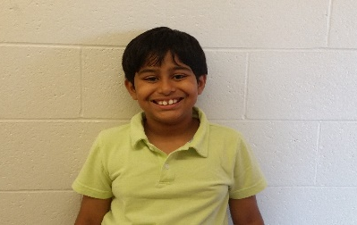
4th Grade
Monday | Gym
Tuesday | Swimming/  Health
Wednesday | Library/  Swep
Thursday | Art
Friday | Music

3rd Grade
Monday | Library/  Swep
Tuesday | Health/  Swimming
Wednesday | Gym
Thursday | Art
Friday | Music

